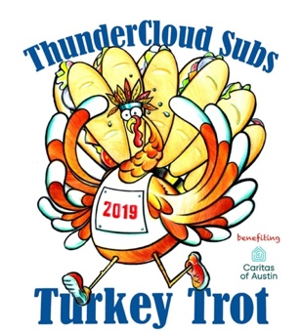
FOR IMMEDIATE RELEASE MEDIA CONTACTS
September 17, 2019 Laine Lieberman, The CKP Group
laine@theckpgroup.com / 832-930-4065 x 124
Julia Davis, The CKP Group
julia@theckpgroup.com / 832-930-4065 x 102

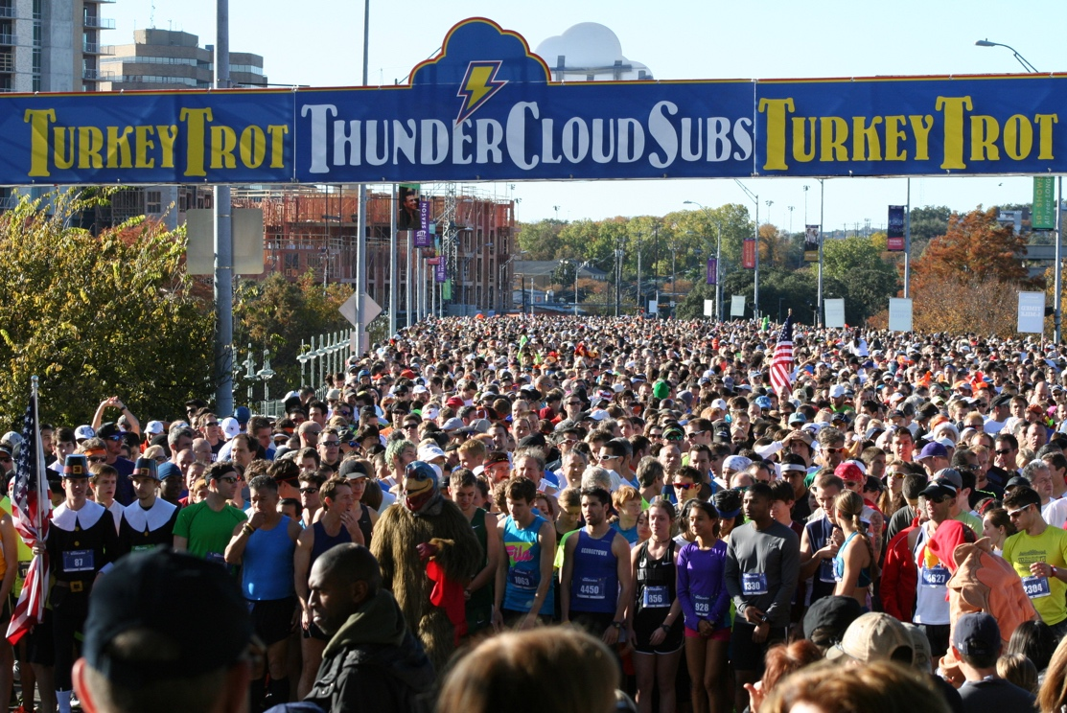

29TH ANNUAL THUNDERCLOUD SUBS TURKEY TROT ANNOUNCES EVENT REGISTRATION & LOGO DESIGN
Early bird registration for the 2019 Trot is open now through October 10

AUSTIN, TX—Early bird registration for the 29th annual ThunderCloud Subs Turkey Trot—one of Austin’s beloved Thanksgiving traditions—is now open. On Thursday, November 28, some 20,000 runners will gather at the Long Center to participate in one of several races: a timed five-mile run, an untimed five-mile run, a one-mile walk or the Stepping Stone School Kids K. The family-friendly event also features live music, children’s activities, a raffle and runner prizes.
Every year, one hundred percent of the proceeds from the Trot go to Caritas of Austin, a local nonprofit dedicated to preventing and ending homelessness for people in Greater Austin. Caritas builds wellbeing by making sure that people have a safe home, access to healthy groceries, jobs that provide a reliable living wage and educational opportunities to learn life skills. Nearly $3.8 million has been raised for Caritas since the Trot’s inception in 1991, with a record $350,000 raised in 2018.

Participants can help raise money for Caritas by registering for the Trot or by entering the 2019 ThunderCloud Subs Turkey Trot Raffle for a chance to win a new Honda Accord Sedan EX CVT courtesy of First Texas Honda, among other prizes. The raffle is open to the public, and participants do not have to register for the Trot or be present to win.

The Trot is made possible by over 600 dedicated volunteers who help run the event each year. Volunteer opportunities for the Trot are available from November 23 to 28 for both individuals and groups, and includes options for check-in and registration, t-shirt distribution, water stops, and event management. Sign-ups are open online.
“We have been proud supporters of the Austin community since our doors opened in 1975. Giving back is at the core of our company culture,” said Mike Haggerty, co-owner of ThunderCloud Subs. “What started as a small fun run with 600 runners has steadily grown into one of the largest Turkey Trots in Texas, allowing us to give nearly $3.8 million Austinites in need over the past 29 years. We love to see our community, customers and employees come together to enjoy such a healthy, family-friendly activity, and the cherry on top is that 100% of the proceeds go to Caritas. That’s what it’s all about—having fun and paying it forward.”
The 2019 winner of the annual Art Contest for the Turkey Trot logo is local artist Karen Smith. Her winning design features a trotting turkey with feathers that resemble ThunderCloud’s signature subs (pictured above). The contest allows Austinites to submit their artwork for a chance to be the featured logo for the race that year and win 365 ThunderCloud Subs vouchers.
Early bird registration, which includes a T-shirt and a run guide, is $22 for the untimed five-mile run; $27 for the timed five-mile run; $20 for the one-mile walk; and $10 for the Stepping Stone School Kid’s K. Registration prices increase on October 10.
To register now, visit thundercloud.com/register. For more information, download the press kit here, visit thundercloud.com/event-info or follow the Turkey Trot on Facebook @ThunderCloudSubsTurkeyTrot.

2019 Turkey Trot Sponsors
First Texas Honda; Pepsi; KVUE; YETI; On Running; JackRabbit; Stepping Stone School; Amica Insurance; Bank of America; Quik Print; The Long Center: New World Bakery; Dr. Pepper; Perdue; Birds Barbershop; Texas Coffee Traders; Sysco, Segovia Produce; Select BankCard; Mellow Johnny’s; Ironbridge Private Wealth; Alori Properties; Alamo Drafthouse; Crane Insurance.
About ThunderCloud Subs
ThunderCloud Subs has been Austin’s original neighborhood sub shop since 1975, with a rich tradition of serving fresh, fast and healthy food in a comfortable atmosphere. ThunderCloud has 31 locations in Central Texas and sells about 3.3 million subs per year. ThunderCloud Subs received the Restaurant Neighbor Award from the Texas Restaurant Association for its outstanding charitable service and dedication to the community, including the ThunderCloud Subs Turkey Trot, a beloved Thanksgiving Day tradition that has raised nearly $3.8 million for Caritas of Austin since its inception in 1991.
###

