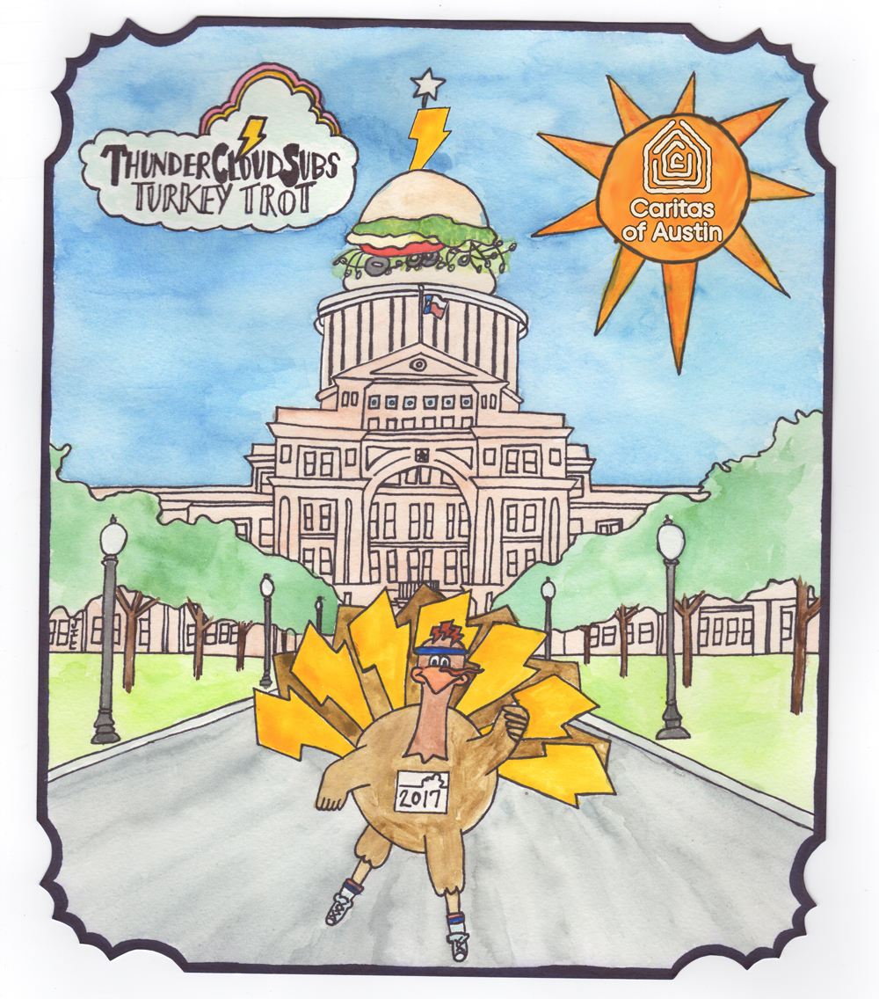

For more information, please contact:
Allison Baron, 682-551-7172
allison@brendathompson.com

August 30, 2017

ThunderCloud Subs Turkey Trot unveils 2017 artwork
and announces event registration

AUSTIN—Early bird registration for the ThunderCloud Subs Turkey Trot is now open with reduced pricing, and the winner of the annual Art Contest has been selected. Jillian Collins won 365 vouchers for free ThunderCloud sandwiches for her watercolor painting of a turkey runner in front of the Texas State Capitol topped with a sub sandwich.

Early registration for the Trot is $20 for the untimed five-mile, $25 for the timed five-mile, $18 for the one-mile walk, and $8 for the Stepping Stone School Kids’ K. All registrations include a T-shirt and runners guide. Registration prices will increase starting Oct. 11. Always held on Thanksgiving Day, the Trot takes place outside the Long Center for the Performing Arts.
All proceeds from the Trot go to Caritas of Austin, a nonprofit organization that supports Austin’s working poor and homeless people. ThunderCloud has raised more than $3 million for Caritas since the event began in 1991.
In addition to receiving a year’s worth of ThunderCloud subs, Collins will see her artwork displayed on 20,000 Thundercloud Subs Turkey Trot T-shirts as well as on social media, posters, and event guides.

Collins says she’ll be most excited to see her artwork on the T-shirts of thousands of people on the Ann and Roy Butler Hike-and-Bike Trail around Lady Bird Lake. Collins is a frequent Trail user herself, and a regular customer at ThunderCloud Subs on Lake Austin Blvd.

“If you run a three mile loop on the Trail at night, you’re guaranteed to see at least one Trot T-shirt— if not half a dozen. It’s great for running when it’s cold outside because of the long sleeves,” Collins says.

Collins learned about the contest two weeks before the deadline, spent a week thinking about her design and planning it, then created the artwork in a two-day burst of creativity, staying up until 4 a.m. to complete it before the deadline.

“I was immediately determined to win! I thought it would be cool to see all the other Trail users wearing my shirt,” says Collins.

Collins did her homework before delving into the creation process, looking online at all the past Trot logos so she could create something different and unique.

The sub depicted on top of the Capitol is the Veggie Delite— Collins’ favorite ThunderCloud sub. “I ordered one, then sat there in front of the Capitol and drew it while looking at the actual sub and building.”

Although she usually visits her family in New Braunfels for Thanksgiving every year, this year all of them are coming to Austin participate in their first ThunderCloud Subs Turkey Trot and to see the artwork displayed everywhere at the run.

The Art Contest to design next year’s artwork will launch on October 11, giving other local artists the chance to win a year’s worth of free ThunderCloud Subs in 2018.
For real-time updates on ThunderCloud Subs Turkey Trot news, events and happenings, like the Facebook page, and connect with ThunderCloud Subs on Twitter and Instagram, @TCloudSubs. To join the online conversation, use #TCloudTrot.
For more information or to register for the ThunderCloud Subs Turkey Trot, visit www.thundercloud.com.
###
About ThunderCloud Subs
Since 1975, ThunderCloud Subs has been Austin’s original neighborhood sub shop, with a rich tradition of serving fresh, fast, and healthy food in a comfortable atmosphere. ThunderCloud has 31 locations in Central Texas and will sell about 3.3 million sub sandwiches this year. ThunderCloud Subs received the Harvey Penick Award for Excellence in the Game of Life in 2015 and the Restaurant Neighbor Award from the Texas Restaurant Association last year for its outstanding charitable service and dedication to the community, including the ThunderCloud Subs Turkey Trot, the beloved Thanksgiving Day tradition that has raised more than $3 million for Caritas of Austin. www.thundercloud.com.

