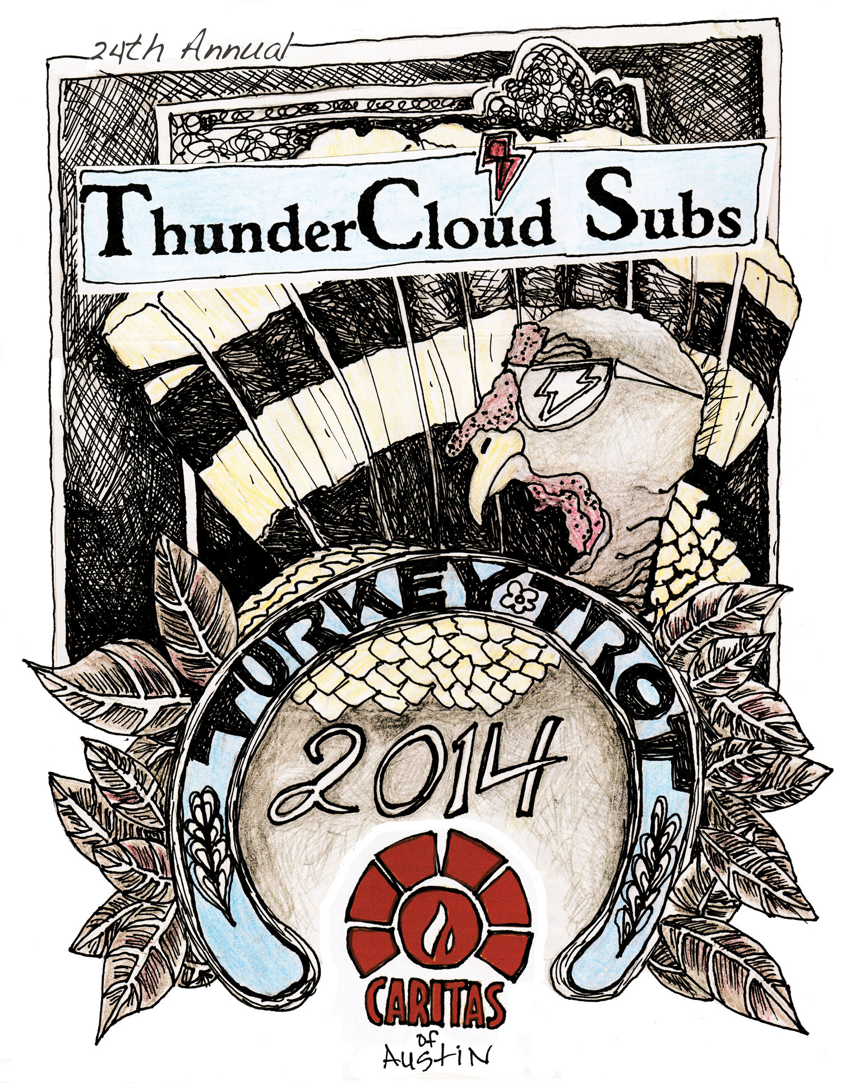

For more information, please contact:
Allison Baron, 682-551-7172
allison@brendathompson.com

November 13, 2014

Turkey Call to kick off holiday season and
ThunderCloud Subs Turkey Trot; Nov. 13

Kids in Thanksgiving costumes, live turkeys at festive contest

WHAT
Dressed in Thanksgiving costumes and handmade turkey hats, Stepping Stone School’s four and five-year-old students will demonstrate their best turkey calls in the hopes that the live turkeys will answer back. The students will also sing festive turkey songs, learn about the live turkeys from its handler, and host a canned food drive for Caritas’ community pantry.

Several judges and the ThunderCloud Subs Turkey Trot mascot will pick a winner for the best turkey call. All kids who participate will receive prizes and ThunderCloud Subs Turkey Trot T-shirts.

WHO
More than 25 four- and five-year-old students from Stepping Stone School, two live wild turkeys from Capitol Zoo, several judges, and the ThunderCloud Subs Turkey Trot mascot.

WHEN
Thursday, Nov. 13 at 10:30 a.m.

WHERE
Stepping Stone School, 8121 Shoal Creek Blvd. (by Steck Ave.)

WHY
The Turkey Call is an annual event to encourage registration for the ThunderCloud Subs Turkey Trot and Stepping Stone School Kids’ K. All proceeds from the ThunderCloud Subs Turkey Trot benefit Caritas of Austin.

BACKGROUND
The 24th annual ThunderCloud Subs Turkey Trot will be held on Thanksgiving Day, Thursday, Nov. 27, at the Long Center for the Performing Arts. The event includes a five-mile run, one-mile walk, and a Kids’ K.

More than 20,000 participants are expected for this year’s event, and all proceeds from the ThunderCloud Subs Turkey Trot go directly to Caritas of Austin, a local nonprofit that supports Austin’s working poor and homeless. The Trot has raised more than $2 million for Caritas of Austin since the tradition began in 1991. Visit www.thundercloud.com for more info.

###

About ThunderCloud Subs
Since 1975,ThunderCloud Subs has been Austin’s original neighborhood sub shop, with a rich tradition of serving fresh, fast, and healthy food in a comfortable atmosphere. ThunderCloud operates 29 locations in Central Texas and sold 3 million sub sandwiches in 2013. ThunderCloud Subs received the Restaurant Neighbor Award from the Texas Restaurant Association in 2014 for its outstanding charitable service and dedication to the community. For more information, visit www.thundercloud.com or call 512-479-8805.

About Stepping Stone School
Stepping Stone School has 18 locations and has cared for more than 50,000 central Texas children since 1979. Serving the community is one of Stepping Stone School’s core values, along with consistently exercising their philanthropic commitment to their community through donations of time, money and resources to organizations whose missions are to better the lives and education of children and families. www.steppingstoneschool.com.

