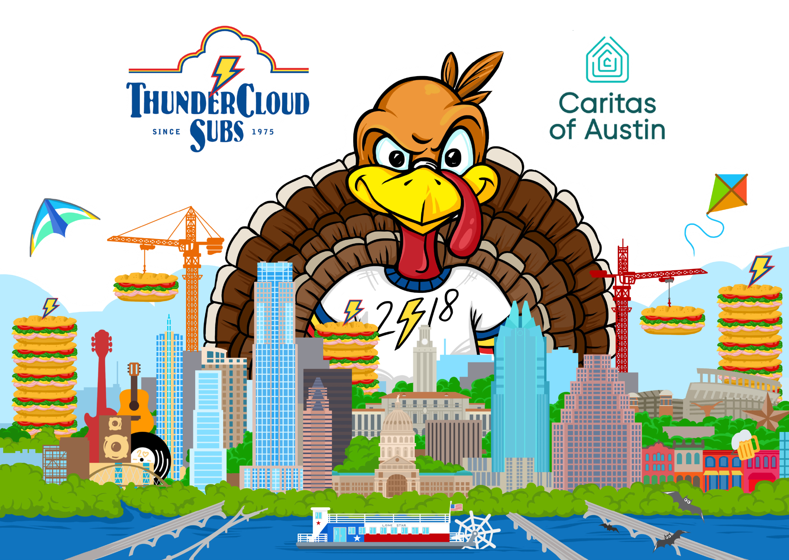

Media Contacts:
Allison Baron, 682-551-7172
allison@brendathompson.com
Brenda Thompson, 512-461-5644
brenda@brendathompson.com

Media note: High-res photos available to view/download at http://thundercloud.com/turkey-trot/media/.

November 16, 2018

ThunderCloud Subs Turkey Trot this Thursday!

WHAT
The 28th annual ThunderCloud Subs Turkey Trot, Austin’s beloved Thanksgiving tradition benefiting Caritas of Austin.

WHEN
Thanksgiving Day, Thursday, Nov. 22—rain or shine!
7:30-9 a.m. | On-site registration / packet pickup
8:45 a.m. | Stepping Stone School Kids K
9:20 a.m. | Pre-run announcements
9:25 a.m. | National Anthem
9:28 a.m. | Wheel chair start
9:30 a.m. | Five-mile run / walk
9:40 a.m. | One-mile run / walk
10:40 a.m. | Trophy pickup begins
10:45 a.m. | Raffle winner announcement

WHERE
The Long Center for Performing Arts, 701 W. Riverside Dr. (Media parking in the circle drive.)

WHY
One hundred percent of the event proceeds benefit Caritas of Austin, a local nonprofit dedicated to preventing and ending homelessness for people in Greater Austin. ThunderCloud has raised nearly $3.5 million for Caritas since the event began in 1991.

VISUALS / FEATURES
More than 20,000 Austinites in costumes of all kinds—turkeys, pilgrims, chefs, Native Americans, cornucopias—and the famous ThunderCloud Turkey Trot T-shirts featuring original artwork by local professional artist Mila Sketch. Live music by Cole Fried Fish, the national anthem by acclaimed singer/songwriter Robin Wiley, children’s activities and face painting, volunteers handing out water and snacks after the run, local neighborhoods along the course cheering on the Trotters, giant signage and photo cutout booths, timed start/finish line with downtown Austin skyline in background, and more.

FAST FACTS
- Online registration is $32 for the untimed 5-mile, $37 for the timed 5-mile, $28 for the 1-mile walk and $12 for the Stepping Stone School Kids K. Prices increase by $5 on Thanksgiving Day and on-site registration is available from 7:30- 9 a.m.
- The ThunderCloud Subs Turkey Trot is the largest five-mile run in Texas and second largest Turkey Trot in the state, with more than 20,000 participants and 600 volunteers.
- Caritas of Austin has a client team participating in the Trot for the seventh year in a row, with 10 clients including Maurice Fowler. Fowler was homeless for many years after his mother passed away, then was introduced to Caritas and started using their services. He has been stably housed for four years and walks the five-mile Trot as part of their annual client team to show his support for the organizations that has done so much for him.
- The Trot is a fun and healthy way to burn some extra calories before that big Thanksgiving meal, and feel good about giving back to the community.
- The Trot also raises money for Caritas through a raffle for a brand new Honda Accord EX-L donated by First Texas Honda and prize packages from YETI and Fairmont Austin, with 100 percent of the raffle ticket sales going directly to Caritas of Austin. Anyone can enter. You don’t need to participate in the Trot or be present to win.
- There are more than 450 teams signed up including We Got the Trots, Gobtrotters, Free The Turkeys, Travis Teacher Trotters, Butterball Express, Rogue Running, and Huffin’ for the Stuffin’, among others.
- Robert “Evil” Evilizer is again our veteran announcer who has been motivating thousands of runners at the ThunderCloud Subs Turkey Trot with his dynamic voice year after year.
- Special run categories include Maternity, Baby Jogger, and Wheelchair (among others), so expect to see oodles of decorated strollers, wagons, and more.
- ThunderCloud employees volunteer more than 1,000 hours to organize and operate the Trot each year. It is truly a labor of love for the entire company.
- To join in the online conversation or enter the photo contest, use #TCloudTrot.

About ThunderCloud Subs
Since 1975, ThunderCloud Subs has been Austin’s original neighborhood sub shop, with a rich tradition of serving fresh, fast, and healthy food in a comfortable atmosphere. ThunderCloud has 31 locations in Central Texas and will sell about 3.3 million sub sandwiches this year. ThunderCloud Subs received the Restaurant Neighbor Award from the Texas Restaurant Association for its outstanding charitable service and dedication to the community, including the ThunderCloud Subs Turkey Trot, the beloved 27-year Thanksgiving Day tradition that has raised nearly $3.5 million for Caritas of Austin. www.thundercloud.com

