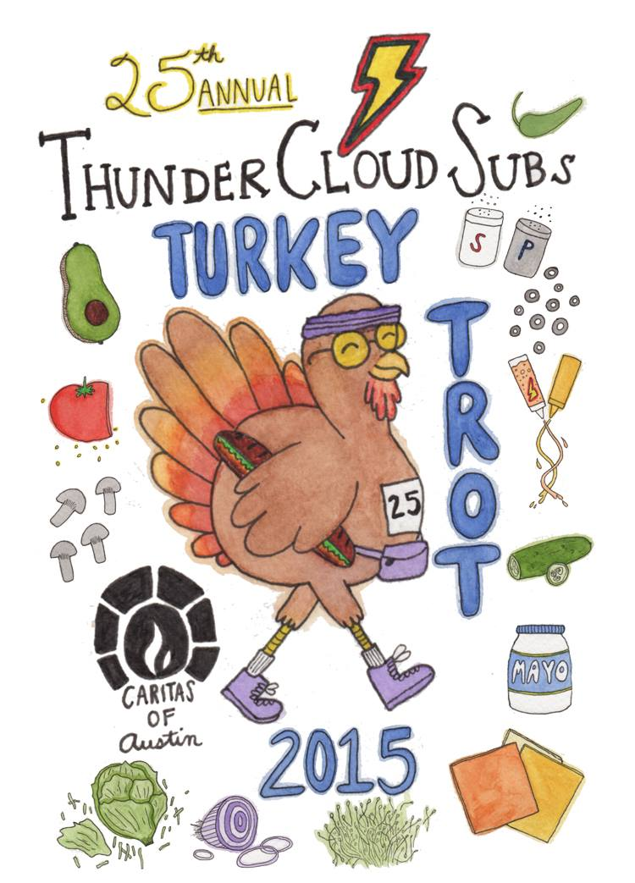

For more information, please contact:
Brenda Thompson, 512-461-5644
brenda@brendathompson.com

Note: high res photos available for download at: http://bit.ly/tcstt

November 9, 2015

25th annual ThunderCloud Subs Turkey Trot
on Thanksgiving Day to benefit Caritas of Austin

Austin’s biggest, most beloved Thanksgiving Day tradition to include raffle for brand new Honda Accord, crazy teams, costumes, more!

AUSTIN—The ThunderCloud Subs Turkey Trot celebrates its 25th anniversary this year (the same year ThunderCloud Subs turns 40)! Austin’s beloved Thanksgiving tradition has raised $2.5 million for Caritas of Austin, which helps people move out of poverty toward self-sufficiency.
The ThunderCloud Subs Turkey Trot is a five-mile run, one-mile walk and a Kids K, beginning and ending at the Long Center for the Performing Arts. Register online at www.thundercloud.com/turkey-trot. All registrations include a T-shirt, runner’s guide, and donation to Caritas.

In its 25 years, the Trot has grown from 600 runners in 1991, to the second largest Thanksgiving Day run in Texas with more than 20,000 participants from 49 states in 2014.

Mike Haggerty, co-owner of ThunderCloud Subs, says this year will include special merrymaking with ThunderCloud celebrating its 40th anniversary and the Trot celebrating its 25th year.

“For the past three years in a row, the number of registrations has hovered right around 21,000 runners. Our goal for 2015 is to register a whopping 25,000 people in honor of the Trot’s 25th anniversary,” Haggerty says.

A longtime Thanksgiving Day tradition for many Austin families and friends, the ThunderCloud Subs Turkey Trot has also become a new pre-game tradition for football fans visiting Austin for Thanksgiving. Continuing the Trot’s football game rivalry run categories, there are special run categories for Longhorns and Red Raiders this year.

Awards will be given to the overall first-place, second-place, and third-place male and female runners, as well as the top three men and women in each age group. Awards will also be given to the first place team and the top three finishers in the following categories: Maternity, Baby Jogger, Wheelchair, Longhorn, Red Raider, and Team Challenge. Participants who want to raise additional money for Caritas of Austin can partake in the Trot’s fundraising challenge for individuals or teams.

Some of the intriguingly-named teams signed up for the Trot are The Flying Dutchmen, Can’t Stop the Gravy Train, Gobble ‘til you Wobble, and We Got the Trots.
First Texas Honda is donating a brand new Honda Accord EX-L as the grand prize for the ThunderCloud Subs Turkey Trot Raffle, with 100 percent of ticket sales going to Caritas. Raffle entrants will also have the chance to win eight gift packages from Mellow Johnny’s with a value totaling $1,250.

Anyone can buy raffle tickets, whether or not participating in the Trot, and ticket-holders do not have to be present to win. Tickets are $25 each or five for $100. Raffle tickets can be purchased online at www.thundercloud.com, at packet pickup before the run, or through an authorized employee or agent of Caritas of Austin at the organization’s headquarters, 611 Neches Street. Winners will be announced on event day at 10:45 a.m.

The Stepping Stone School Kids K will begin at 8:45 a.m., the timed five-mile starts at 9:30 a.m., the untimed five-mile starts immediately afterwards, then the one-mile walk starts immediately after that. Winners will be announced and awarded after the run at 10:40 a.m.

Online registration for the ThunderCloud Subs Turkey Trot is $25 for the untimed five-mile, $30 for the timed five-mile, $20 for the one-mile walk, and $8 for the Stepping Stone School Kids’ K.

For real-time updates on ThunderCloud Subs Turkey Trot news, events and happenings, like the Facebook page, and connect with ThunderCloud Subs on Twitter and Instagram, @TCloudSubs. To join in the online conversation, use #TCloudTrot.

For more information or to register for the ThunderCloud Subs Turkey Trot, visit www.thundercloud.com/turkey-trot.

About ThunderCloud Subs
Since 1975, ThunderCloud Subs has been Austin’s original neighborhood sub shop, with a rich tradition of serving fresh, fast, and healthy food in a comfortable atmosphere. ThunderCloud has 31 locations in Central Texas and will sell about 3.3 million sub sandwiches this year. ThunderCloud Subs received the Restaurant Neighbor Award from the Texas Restaurant Association last year for its outstanding charitable service and dedication to the community, including the ThunderCloud Subs Turkey Trot, the beloved 25-year Thanksgiving Day tradition that has raised $2.5 million for Caritas of Austin. For more information, visit www.thundercloud.com or call 512-479-8805.

