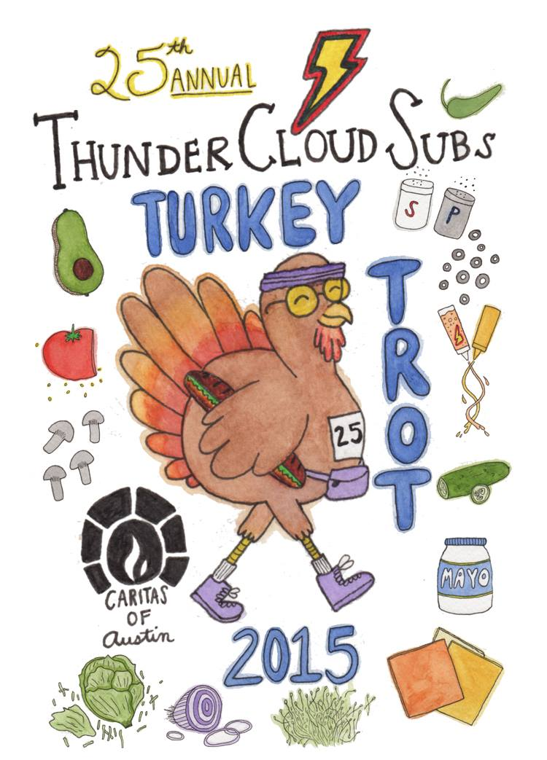

Media Contacts:
Brenda Thompson, 512-461-5644
brenda@brendathompson.com

Allison Baron, 682-551-7172
allison@brendathompson.com

Note: high res photos available for download at: http://bit.ly/tcstt

November 25, 2015

ThunderCloud Subs Turkey Trot tomorrow!
More than 20,000 to celebrate 25th anniversary of Austin’s
favorite Thanksgiving Day tradition benefitting Caritas

WHAT
The 25th annual ThunderCloud Subs Turkey Trot, Austin’s favorite Thanksgiving tradition benefiting Caritas of Austin.

WHEN
Thanksgiving Day, Thursday, Nov. 26— rain or shine!
7:30- 9:30 a.m. | Registration / Packet pickup
8:45 a.m. | Stepping Stone School Kids’ K
9:25 a.m. | Wheelchair start
9:30 a.m. | Five-mile run / walk
9:45 a.m. | One-mile run / walk
10:45 a.m. | Raffle announcement/ Trophy pickup

WHERE
The Long Center for the Performing Arts (media parking is in the circle drive)

WHY
One hundred percent of event proceeds benefit Caritas of Austin, a nonprofit organization that helps people move out of poverty toward self-sufficiency. ThunderCloud has raised $2.5 million for Caritas since founding the Trot in 1991.

VISUALS
More than 20,000 participants, many in creative Thanksgiving-themed costumes including turkeys, Indians, pilgrims, turkey jockeys, cornucopias, and more; a rock ‘n roll band playing live music with Austin’s skyline behind them; 600-plus volunteers; trophies and raffle prizes including a brand new First Texas Honda Accord; the scenic Long Center grounds with views of the downtown skyline; hundreds of kids’ participating in the Stepping Stone Kid’s K and children’s activities including face painting; and more.

FAST FACTS
- This year marks the 25th anniversary of the ThunderCloud Subs Turkey Trot AND the 40th anniversary of ThunderCloud Subs!
- In its 25 years, the Trot has grown from 600 runners in 1991, to the second largest Thanksgiving Day run in Texas with more than 20,000 participants from 49 states in 2014.
- Last year’s Trot raised $335,000 for Caritas— that’s $16.25 to Caritas from every participant.
- A favorite pre-game tradition for many football fans, the Trot continues its football rivalry tradition this year with special categories for Red Raiders and Longhorns. Other categories are: Maternity, Baby Jogger, Wheelchair, and Team Challenge.
- The winner of this year’s competition to design the logo for the ThunderCloud Subs Turkey Trot was Elizabeth Reeves. In addition to having her artwork plastered on more than 20,000 T-shirts, run guides, and promo materials, Reeves also won a year’s worth of free ThunderCloud subs.
- More than 200 teams are signed up for the Trot this year including The Flying Dutchmen, Can’t Stop the Gravy Train, Gobble ‘til you Wobble, We Got the Trots, Gobtrotters, Free The Turkeys, and Turkey Leg.
- The second annual photo contest encourages participants to share their event-day photos on social media for a chance to win two free run entries into next year’s Trot and $50 worth of free ThunderCloud subs.

Visit www.thundercloud.com/turkey-trot for more information. To join in the online conversation, use #TCloudTrot.

###

About ThunderCloud Subs
Since 1975, ThunderCloud Subs has been Austin’s original neighborhood sub shop, with a rich tradition of serving fresh, fast, and healthy food in a comfortable atmosphere. ThunderCloud has 31 locations in Central Texas and will sell about 3.3 million sub sandwiches this year. ThunderCloud Subs received the Restaurant Neighbor Award from the Texas Restaurant Association last year for its outstanding charitable service and dedication to the community, including the ThunderCloud Subs Turkey Trot, the beloved 25-year Thanksgiving Day tradition that has raised $2.5 million for Caritas of Austin. For more information, visit www.thundercloud.com or call 512-479-8805.

