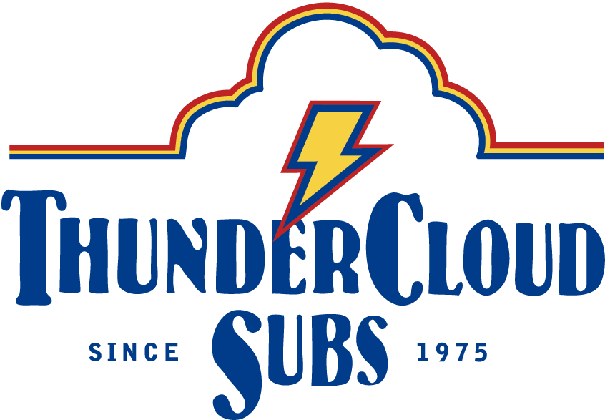

ThunderCloud Subs Facts and FAQ

- Who founded ThunderCloud Subs?
Andy Cotton and John Meddaugh founded ThunderCloud Subs in 1975 in Austin with the simple philosophy of selling a fresh meal at a reasonable price, and we proudly maintain that same philosophy today.

Who is ThunderCloud’s leadership team?
Andy Cotton: CEO and co-founder
John Meddaugh: President and co-founder
Mike Haggerty: Co-owner
Patty Sughrue: COO

- How long has ThunderCloud Subs been in Austin?
ThunderCloud Subs was founded in Austin in 1975, and has been a proud member of the community ever since.

- What makes ThunderCloud Subs an iconic Austin business?
The people—our fiercely loyal customers, and the longevity of so many of our great employees—have helped make ThunderCloud Subs one of the city’s favorite Austin-original businesses. Our great food and contributions to the community also inspire loyalty.

- Which ThunderCloud Subs location is the first store?
1608 Lavaca St. was the first store, and opened in 1975.

- How many stores does ThunderCloud Subs have? Where are they located?
ThunderCloud Subs has 30 stores in Austin and Central Texas. Austin's neighboring cities with ThunderCloud stores are Bee Cave, Dripping Springs, Round Rock, Pflugerville, Cedar Park, New Braunfels, San Antonio, and Georgetown. We also have a location at the Austin-Bergstrom Airport.

- How many people does ThunderCloud Subs employ?
ThunderCloud has approximately 400 employees.

- Where does ThunderCloud get its food?
ThunderCloud is very particular about the ingredients in all of its food, and uses food from local vendors as much as possible. Our bread comes from Austin’s New World Bakery, our produce from Segovia (the oldest locally owned and operated produce distribution company in Central Texas), our organic eggs from Austin’s Vital Farms, and some of our stores carry LaLa’s Lemonade.

- Do you have gluten-free items on your menu?
All ThunderCloud locations offer gluten-free bread.

- How many locations have online ordering?
There are 18 ThunderCloud Subs stores that have online ordering available.

- How does ThunderCloud Subs give back to the community? What charitable organizations does ThunderCloud Subs support?
We believe in supporting local organizations dedicated to creating a better community and supporting values that Austin cares about. Each year, ThunderCloud sponsors popular events that bring the Austin community together for meaningful causes. We dedicate half of our annual marketing effort to support local non-profit groups. Our signature event is the ThunderCloud Subs Turkey Trot, the largest five-mile run in Texas, with more than 20,000 people participating on Thanksgiving Day. Since it began in 1991, the Turkey Trot has raised nearly $2.5 million for Caritas of Austin, which fights poverty, hunger, and homelessness. Last year alone, ThunderCloud Subs Turkey Trot raised more than $325,000 for Caritas.

ThunderCloud also participates in the annual “Give 5 to Mother Earth” campaign, in which local businesses donate 5 percent of our sales from Earth Day to a group of environmentally based non-profits, including the Austin Parks Foundation, Clean Water Fund, Friends of Barton Springs Pool, Health Alliance for Austin Musicians, Hill Country Conservancy, Texas Land Conservancy, Tree Folks, and Urban Roots. We also support numerous local schools.

- What’s the deal with the college tuition reimbursement plan ThunderCloud Subs offers for employees?
ThunderCloud offers a college tuition reimbursement plan for qualifying employees, in which we will reimburse 25 percent of their college tuition ($400 maximum per semester). This benefit is available to employees working 20 hours per week who are taking nine hours per college semester with a C average or better.

- Where is ThunderCloud Subs headquarters?
Our two offices are located at 1102 West Sixth St., Austin, TX 78703; and at 201 East Riverside Drive, Austin, TX 78704. If you would like to get in touch with us, you can give us a call at 512-479-8805 or send us an email at info@thundercloud.com

- What is ThunderCloud Subs most popular menu item?
The California Club is our most popular menu item.
- How can I get real-time updates on ThunderCloud Subs latest news, specials, events, and happenings?
Connect with us on social media! Be a fan of ThunderCloud Subs and the ThunderCloud Subs Turkey Trot on Facebook, facebook.com/ThunderCloudSubs and facebook.com/ThunderCloudSubsTurkeyTrot. Follow us on Instagram, instagram.com/TCloudSubs, and Twitter, twitter.com/TCloudSubs, at @TCloudSubs. Join the online conversation with #ThunderCloudSubs and #ATXTurkeyTrot.

